Isometry

Definition
# Source: AI Source: Provided by: [Data Path: Persons Table -> ID Column: 1, Name_En Column: Motasem Essam] -> From: [ChatGPT] on [7/25/2026]
An Isometry is a geometric transformation that preserves the distance between every pair of points.
If $T$is an isometry and $P,Q$are any two points, then:
$$\boxed{d\left(T , \left(P\right)T\left(Q\right)\right)=d\left(P , Q\right)}$$
Therefore, an isometry preserves the size and shape of a geometric figure.
In Euclidean geometry, isometries are also called distance-preserving transformations or rigid transformations.
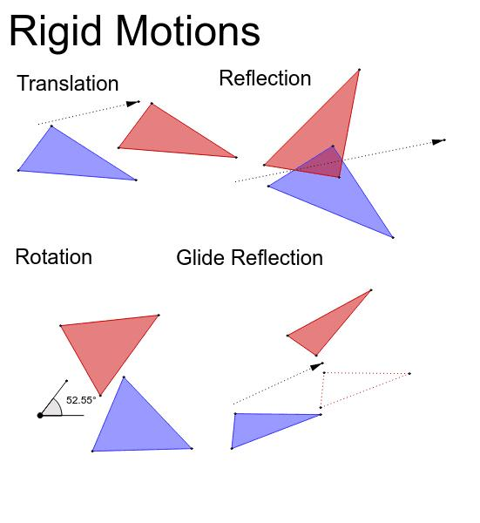
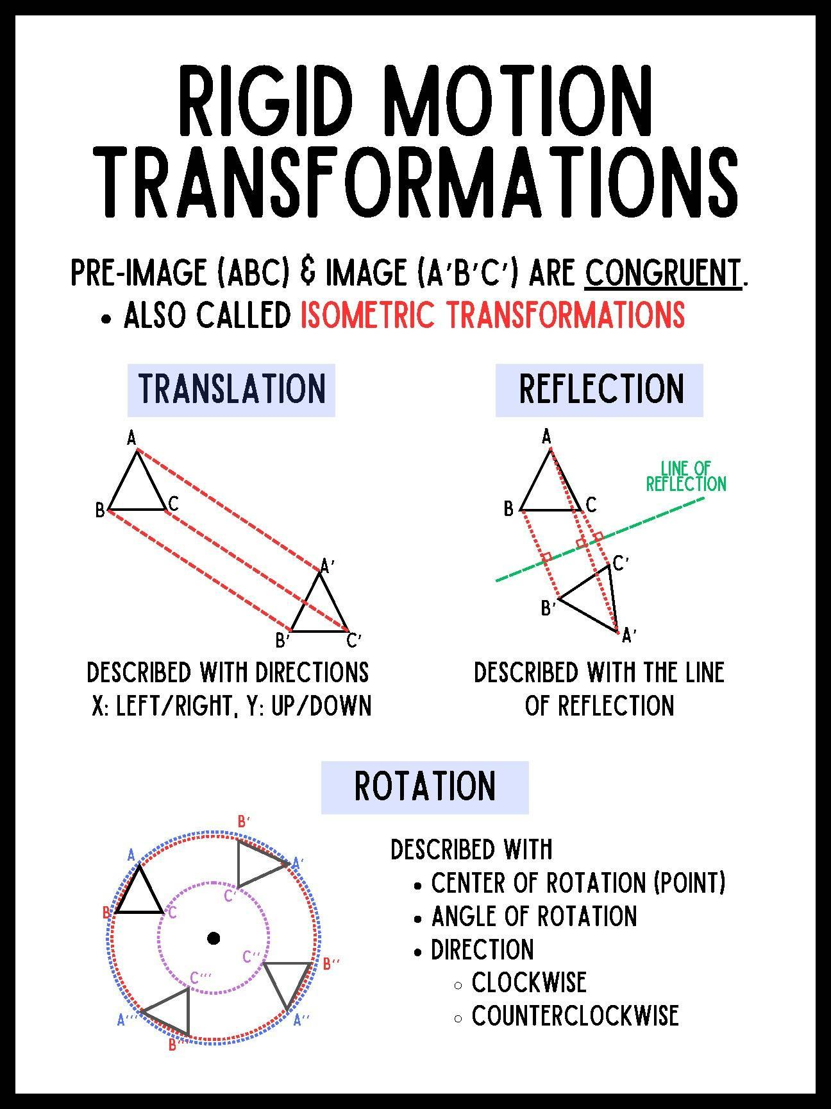
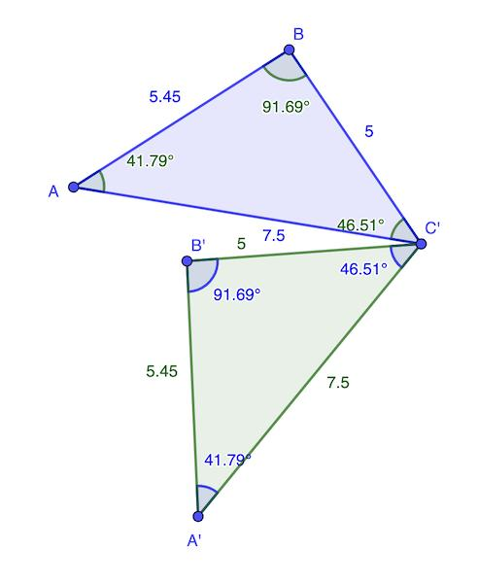
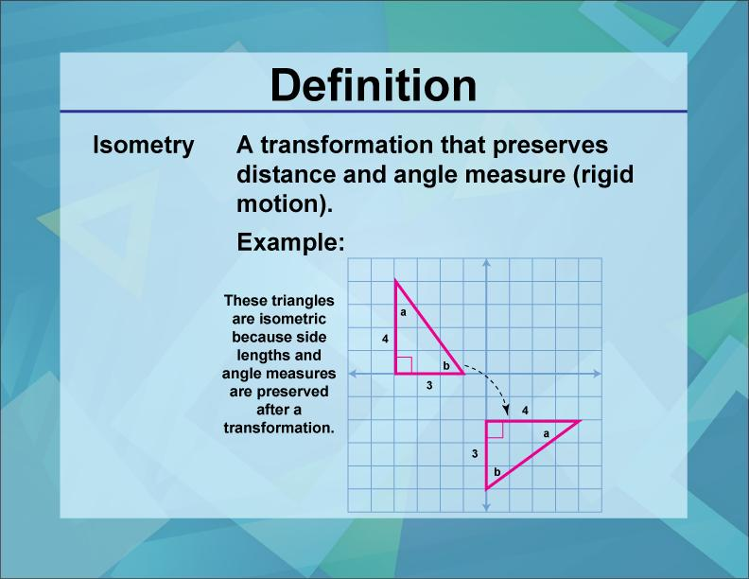
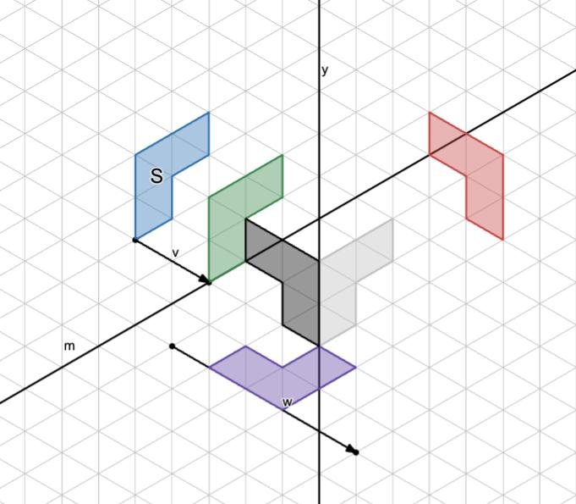

Fundamental Concept
# Source: AI Source: Provided by: [Data Path: Persons Table -> ID Column: 1, Name_En Column: Motasem Essam] -> From: [ChatGPT] on [7/25/2026]
The essential property of an isometry is:
$$\boxed{\text{Distance Preservation}}$$
If:
$$P→P^{'}$$
and:
$$Q→Q^{'}$$
then:
$$\boxed{PQ=P^{'}Q^{'}}$$
The figure may move or change orientation, but it does not stretch, shrink, or distort.
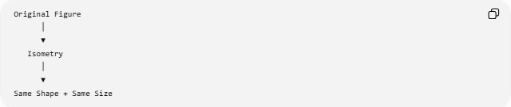
Original Figure
│
▼
Isometry
│
▼
Same Shape + Same Size

Basic Structure
# Source: AI Source: Provided by: [Data Path: Persons Table -> ID Column: 1, Name_En Column: Motasem Essam] -> From: [ChatGPT] on [7/25/2026]
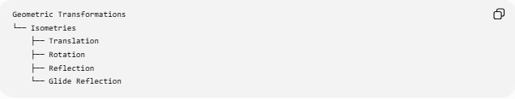
Geometric Transformations
└── Isometries
├── Translation
├── Rotation
├── Reflection
└── Glide Reflection
These are the fundamental Euclidean isometries of the plane.

Main Characteristics
# Source: AI Source: Provided by: [Data Path: Persons Table -> ID Column: 1, Name_En Column: Motasem Essam] -> From: [ChatGPT] on [7/25/2026]
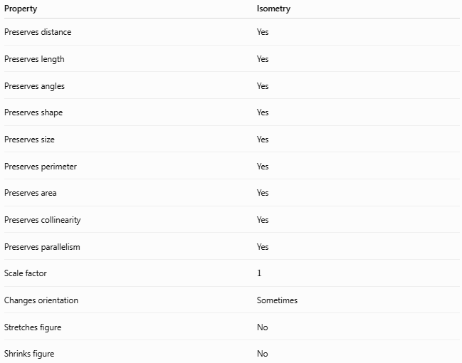
Property | Isometry
Preserves distance | Yes
Preserves length | Yes
Preserves angles | Yes
Preserves shape | Yes
Preserves size | Yes
Preserves perimeter | Yes
Preserves area | Yes
Preserves collinearity | Yes
Preserves parallelism | Yes
Scale factor | $$1$$
Changes orientation | Sometimes
Stretches figure | No
Shrinks figure | No

Distance Preservation
# Source: AI Source: Provided by: [Data Path: Persons Table -> ID Column: 1, Name_En Column: Motasem Essam] -> From: [ChatGPT] on [7/25/2026]
The defining equation is:
$$\boxed{d\left(T , \left(P\right)T\left(Q\right)\right)=d\left(P , Q\right)}$$
For points:
$$P=\left(x_{1} , y_{1}\right)$$
and:
$$Q=\left(x_{2} , y_{2}\right)$$
their distance is:
$$PQ=\sqrt{{\left(x_{2}-x_{1}\right)}^{2}+{\left(y_{2}-y_{1}\right)}^{2}}$$
After an isometry:
$$P^{'}=T\left(P\right), Q^{'}=T\left(Q\right)$$
we have:
$$\boxed{P^{'}Q^{'}=PQ}$$

Types of Isometry

1-Translation
# Source: AI Source: Provided by: [Data Path: Persons Table -> ID Column: 1, Name_En Column: Motasem Essam] -> From: [ChatGPT] on [7/25/2026]
A translation moves every point the same distance in the same direction.
$$\boxed{\left(x , y\right)→\left(x , +ay+b\right)}$$
It preserves both size and orientation.

2-Rotation
# Source: AI Source: Provided by: [Data Path: Persons Table -> ID Column: 1, Name_En Column: Motasem Essam] -> From: [ChatGPT] on [7/25/2026]
A rotation turns a figure around a fixed center.
For a rotation about the origin:
$$\boxed{x^{'}=x\cos{θ}-y\sin{θ}} \\ \boxed{y^{'}=x\sin{θ}+y\cos{θ}}$$
It preserves size, shape, and orientation.

3-Reflection
# Source: AI Source: Provided by: [Data Path: Persons Table -> ID Column: 1, Name_En Column: Motasem Essam] -> From: [ChatGPT] on [7/25/2026]
A reflection flips a figure across a line.
For reflection across the $x$-axis:
$$\boxed{\left(x , y\right)→\left(x , -y\right)}$$
It preserves size and shape but reverses orientation.

4-Glide Reflection
# Source: AI Source: Provided by: [Data Path: Persons Table -> ID Column: 1, Name_En Column: Motasem Essam] -> From: [ChatGPT] on [7/25/2026]
A glide reflection combines:
- a reflection, and
- a translation parallel to the reflection line.
$$\boxed{G=T_{\vec{v}}∘R_{l}}$$
where:
$$\vec{v}∥l$$
It preserves size and shape but reverses orientation.

Classification by Orientation
# Source: AI Source: Provided by: [Data Path: Persons Table -> ID Column: 1, Name_En Column: Motasem Essam] -> From: [ChatGPT] on [7/25/2026]
Isometries can be divided into two groups.
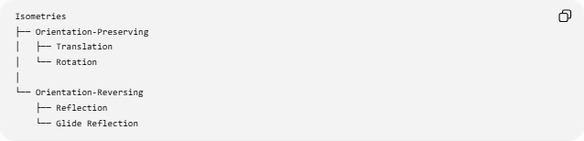
Isometries
├── Orientation-Preserving
│ ├── Translation
│ └── Rotation
│
└── Orientation-Reversing
├── Reflection
└── Glide Reflection
Orientation-Preserving
The clockwise/counterclockwise ordering of points remains unchanged.
Examples:
$$\boxed{\text{Translation, Rotation}}$$
Orientation-Reversing
The ordering is reversed.
Examples:
$$\boxed{\text{Reflection, Glide Reflection}}$$

Isometry and Congruence
# Source: AI Source: Provided by: [Data Path: Persons Table -> ID Column: 1, Name_En Column: Motasem Essam] -> From: [ChatGPT] on [7/25/2026]
An isometry maps a figure to a congruent figure.
Therefore:
$$\boxed{\text{Isometry}⇒\text{Congruence}}$$
If:
$$S^{'}=T\left(S\right)$$
where $T$is an isometry, then:
$$\boxed{S^{'}≅S}$$
This is why congruence transformations are also called isometries.

Isometry vs Congruence Transformation
# Source: AI Source: Provided by: [Data Path: Persons Table -> ID Column: 1, Name_En Column: Motasem Essam] -> From: [ChatGPT] on [7/25/2026]
These terms are closely related but emphasize different ideas.

Term | Main Emphasis
Isometry | Preservation of distance
Congruence Transformation | Mapping one figure to a congruent figure
Mathematically, in Euclidean geometry:
$$\boxed{\text{Congruence Transformation}=\text{Isometry}}$$

Isometry vs Similarity Transformation
# Source: AI Source: Provided by: [Data Path: Persons Table -> ID Column: 1, Name_En Column: Motasem Essam] -> From: [ChatGPT] on [7/25/2026]
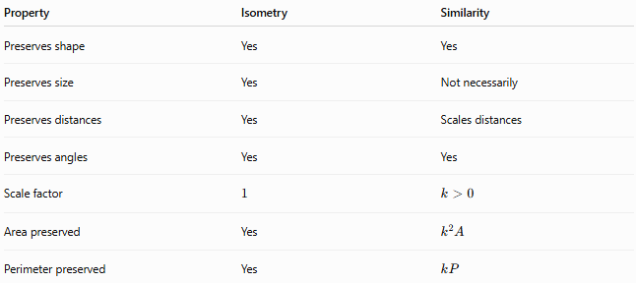
Property | Isometry | Similarity
Preserves shape | Yes | Yes
Preserves size | Yes | Not necessarily
Preserves distances | Yes | Scales distances
Preserves angles | Yes | Yes
Scale factor | $$1$$ | $$k>0$$
Area preserved | Yes | $$k^{2}A$$
Perimeter preserved | Yes | $$kP$$
The defining difference is:
$$\boxed{\text{Isometry: }k=1}$$
while a general similarity transformation can have:
$$\boxed{k≠1}$$

Isometry vs Homothety
# Source: AI Source: Provided by: [Data Path: Persons Table -> ID Column: 1, Name_En Column: Motasem Essam] -> From: [ChatGPT] on [7/25/2026]
A homothety scales distances from a fixed center:
$$OP^{'}=∣k∣OP$$
An isometry requires:
$$\boxed{k=1}$$
in terms of distance scaling.
Thus, a nontrivial homothety with:
$$∣k∣≠1$$
is not an isometry.
The special case:
$$k=-1$$
is a ${180}^{∘}$rotation and is an isometry because:
$$∣-1∣=1$$

Angle Preservation
# Source: AI Source: Provided by: [Data Path: Persons Table -> ID Column: 1, Name_En Column: Motasem Essam] -> From: [ChatGPT] on [7/25/2026]
Because distances are preserved, an isometry also preserves angle measures.
If:
$$m∠ABC=θ$$
then:
$$\boxed{m∠A^{'}B^{'}C^{'}=θ}$$
Thus:
$$\boxed{\text{Distances and angles are preserved}}$$

Area Preservation
# Source: AI Source: Provided by: [Data Path: Persons Table -> ID Column: 1, Name_En Column: Motasem Essam] -> From: [ChatGPT] on [7/25/2026]
An isometry does not change the size of a figure.
Therefore:
$$\boxed{A^{'}=A}$$
For example, if:
$$A=25{\text{ cm}}^{2}$$
then after an isometry:
$$\boxed{A^{'}=25{\text{ cm}}^{2}}$$

Perimeter Preservation
# Source: AI Source: Provided by: [Data Path: Persons Table -> ID Column: 1, Name_En Column: Motasem Essam] -> From: [ChatGPT] on [7/25/2026]
Since every side length remains unchanged:
$$\boxed{P^{'}=P}$$
For example:
$$P=30\text{ cm}$$
remains:
$$\boxed{P^{'}=30\text{ cm}}$$

Example
# Source: AI Source: Provided by: [Data Path: Persons Table -> ID Column: 1, Name_En Column: Motasem Essam] -> From: [ChatGPT] on [7/25/2026]
Consider:
$$A=\left(1 , 2\right)$$
and:
$$B=\left(4 , 2\right)$$
The original distance is:
$$AB=3$$
Translate both points by:
$$\left(5 , -1\right)$$
Then:
$$A^{'}=\left(6 , 1\right) \\ B^{'}=\left(9 , 1\right)$$
The new distance is:
$$A^{'}B^{'}=3$$
Therefore:
$$\boxed{AB=A^{'}B^{'}}$$
The translation is an isometry.

Coordinate Representation
# Source: AI Source: Provided by: [Data Path: Persons Table -> ID Column: 1, Name_En Column: Motasem Essam] -> From: [ChatGPT] on [7/25/2026]
A Euclidean isometry can generally be represented as:
$$\boxed{x^{'}=Ax+b}$$
where:
- $A$is an orthogonal matrix,
- $b$is a translation vector.
The defining condition for $A$is:
$$\boxed{A^{T}A=I}$$
This guarantees that distances are preserved.

Determinant and Orientation
# Source: AI Source: Provided by: [Data Path: Persons Table -> ID Column: 1, Name_En Column: Motasem Essam] -> From: [ChatGPT] on [7/25/2026]
For a planar isometry represented by an orthogonal matrix $A$:
$$det⁡\left(A\right)=±1$$
If:
$$\boxed{det⁡\left(A\right)=1}$$
the linear part preserves orientation.
This corresponds to rotations and the identity.
If:
$$\boxed{det⁡\left(A\right)=-1}$$
the linear part reverses orientation.
This corresponds to reflections and reflection-containing isometries.

Composition of Isometries
# Source: AI Source: Provided by: [Data Path: Persons Table -> ID Column: 1, Name_En Column: Motasem Essam] -> From: [ChatGPT] on [7/25/2026]
The composition of two isometries is another isometry.
If:
$$T_{1}$$
and:
$$T_{2}$$
are isometries, then:
$$\boxed{T_{2}∘T_{1}}$$
is also an isometry.
Therefore:
$$\boxed{\text{Isometry}∘\text{Isometry}=\text{Isometry}}$$
This explains why combinations of translations, rotations, reflections, and glide reflections remain distance-preserving.

Inverse of an Isometry
# Source: AI Source: Provided by: [Data Path: Persons Table -> ID Column: 1, Name_En Column: Motasem Essam] -> From: [ChatGPT] on [7/25/2026]
Every Euclidean isometry has an inverse that is also an isometry.
$$\boxed{T^{-1}∘T=I}$$
and:
$$\boxed{T∘T^{-1}=I}$$
Examples:
- Translation by $\left(a , b\right)$→ inverse translation by $\left(- , a-b\right)$
- Rotation by $θ$→ inverse rotation by $-θ$
- Reflection → itself
- Glide reflection → inverse glide reflection

Identity Isometry
# Source: AI Source: Provided by: [Data Path: Persons Table -> ID Column: 1, Name_En Column: Motasem Essam] -> From: [ChatGPT] on [7/25/2026]
The identity transformation leaves every point unchanged:
$$\boxed{I\left(P\right)=P}$$
It is an isometry because:
$$d\left(I , \left(P\right)I\left(Q\right)\right)=d\left(P , Q\right)$$
The identity is the simplest isometry.

Isometry and Geometric Properties
# Source: AI Source: Provided by: [Data Path: Persons Table -> ID Column: 1, Name_En Column: Motasem Essam] -> From: [ChatGPT] on [7/25/2026]
An isometry preserves:
Linear Properties
$$\boxed{\text{Lengths}}$$
Angular Properties
$$\boxed{\text{Angles}}$$
Boundary Properties
$$\boxed{\text{Perimeter}}$$
Regional Properties
$$\boxed{\text{Area}}$$
Structural Properties
$$\boxed{\text{Shape, Collinearity, Parallelism}}$$

Classification Summary
# Source: AI Source: Provided by: [Data Path: Persons Table -> ID Column: 1, Name_En Column: Motasem Essam] -> From: [ChatGPT] on [7/25/2026]
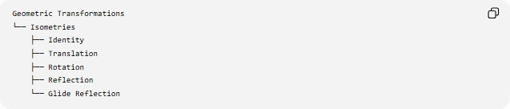
Geometric Transformations
└── Isometries
├── Identity
├── Translation
├── Rotation
├── Reflection
└── Glide Reflection
By orientation:
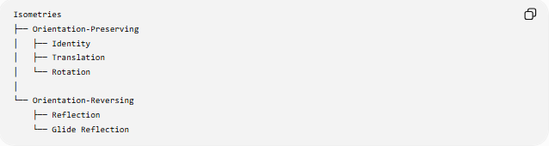
Isometries
├── Orientation-Preserving
│ ├── Identity
│ ├── Translation
│ └── Rotation
│
└── Orientation-Reversing
├── Reflection
└── Glide Reflection

Key Points
# Source: AI Source: Provided by: [Data Path: Persons Table -> ID Column: 1, Name_En Column: Motasem Essam] -> From: [ChatGPT] on [7/25/2026]
- Isometry means a distance-preserving transformation.
- Its defining equation is:
$$\boxed{d\left(T , \left(P\right)T\left(Q\right)\right)=d\left(P , Q\right)}$$
- It preserves:
  - distances,
  - lengths,
  - angles,
  - shape,
  - size,
  - perimeter,
  - area.
- The fundamental plane isometries are:
  - Identity
  - Translation
  - Rotation
  - Reflection
  - Glide Reflection
- Isometries preserve congruence.
- The composition of isometries is an isometry.
- Every Euclidean isometry has an inverse that is also an isometry.
- Isometries have scale factor $1$in terms of distance.

Conclusion
# Source: AI Source: Provided by: [Data Path: Persons Table -> ID Column: 1, Name_En Column: Motasem Essam] -> From: [ChatGPT] on [7/25/2026]
An Isometry is a transformation that preserves the distance between every pair of points:
$$\boxed{d\left(T , \left(P\right)T\left(Q\right)\right)=d\left(P , Q\right)}$$
Consequently, it preserves the shape, size, lengths, angles, perimeter, and area of a geometric figure.
The fundamental Euclidean isometries are:
$$\boxed{\text{Identity, Translation, Rotation, Reflection, Glide Reflection}}$$
Thus, an isometry is the mathematical foundation of rigid motion and congruence: a figure may move, rotate, or reverse its orientation, but it cannot be stretched, compressed, or resized.

